**Blackboard Bulk Download instructions**

**Hyeon-Seo Yun**

Hello, my name is Hyeon-Seo Yun, and this my guide in how to use my program!

This program allows you to download assignments from Blackboard **only** from students in your lab/rec group. You can already download assignments on Blackboard, but you can’t sort by lab/rec groups, so good luck downloading 1,300 submissions all at once just to grade 80 of them.

BTW, I am a lab TA, so I’m gonna assume that we are all lab TAs here for simplicity. If you don’t like that, then please speak to my manager.

**Why is this code useful ? (skip if you already think it is)**

Now why automatically download assignments? Well, if you’re like me, you would be getting a little crazy from the fact that now you have to grade **every** single submission thanks to the COVID 19 pandemic. I mean, I am fine grading all that, but blackboard is slow going from one page to another, which means I have to wait possibly up to a minute to go from one assignment to another.

This **reallllly** bugs me. I would rather just download all the assignment at once so I can open/close them immediately offline; ergo, this code.

**Installation:**

There are several prerequisites for my program to work. However, please keep in mind that these are not strict requirements and you are required to play around as you see fit.

**Prerequisites:**

* Python 3
* Selenium in Python
* Web Browser (**Chrome**/ Firefox/ Edge)

Please note that in my testing, the program works in Windows 10, using Chrome.

After some tries, I could not manage to get Firefox and Microsoft Edge to work.

**Installing Selenium for Python**

Let’s assume you already know how to install Python 3 and a Web Browser of your choice.

Installing Selenium in Python:

This is quite simple, you just follow the instructions written here is shown in <https://selenium-python.readthedocs.io/installation.html#drivers>:

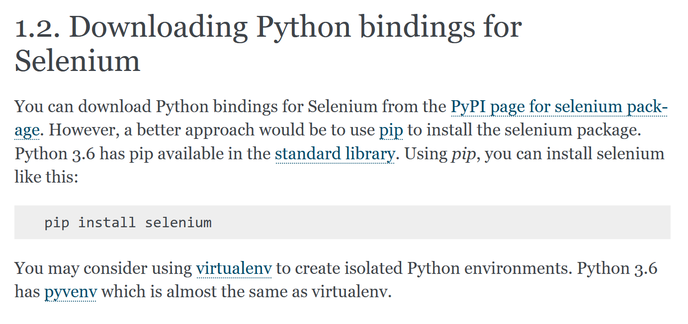

There are many good tutorials in how to install pip online, so I’ll assume you have that installed.

**Downloading Driver and adding it to your System Path**

Now you need to download the browser driver of your choice and add it to the system path.

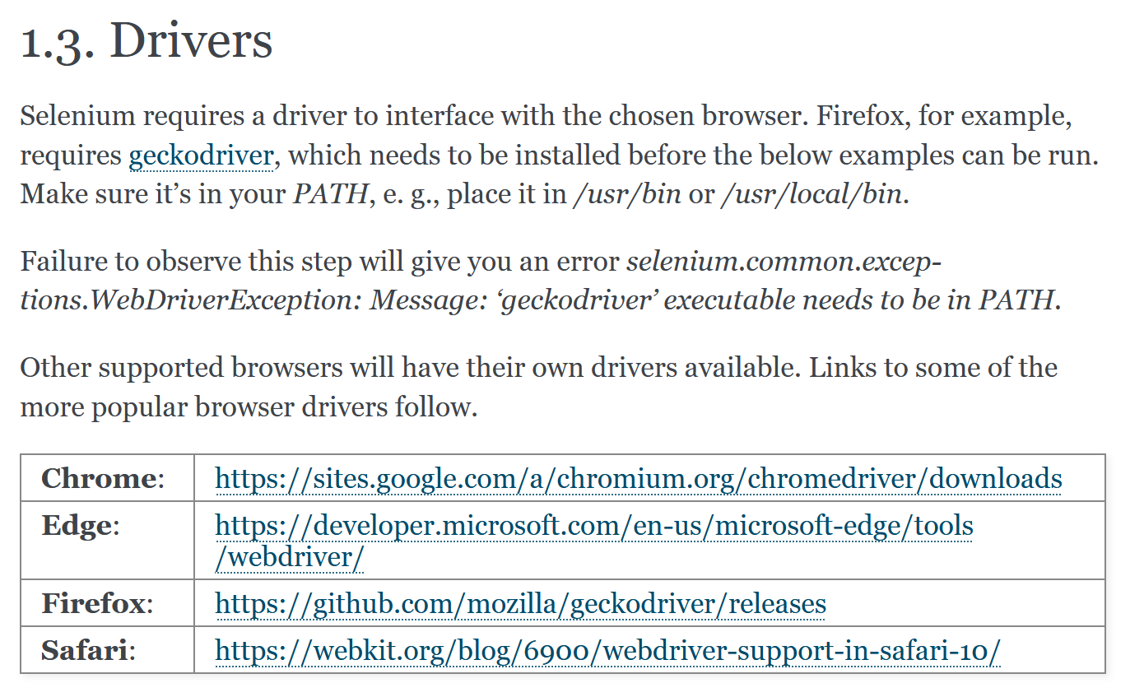

The image above is still from the previously mentioned website <https://selenium-python.readthedocs.io/installation.html#drivers>.

I recommend using chrome for the time being, so let’s quickly look at my version of the Chrome I have installed by going to “About Google Chrome page.”

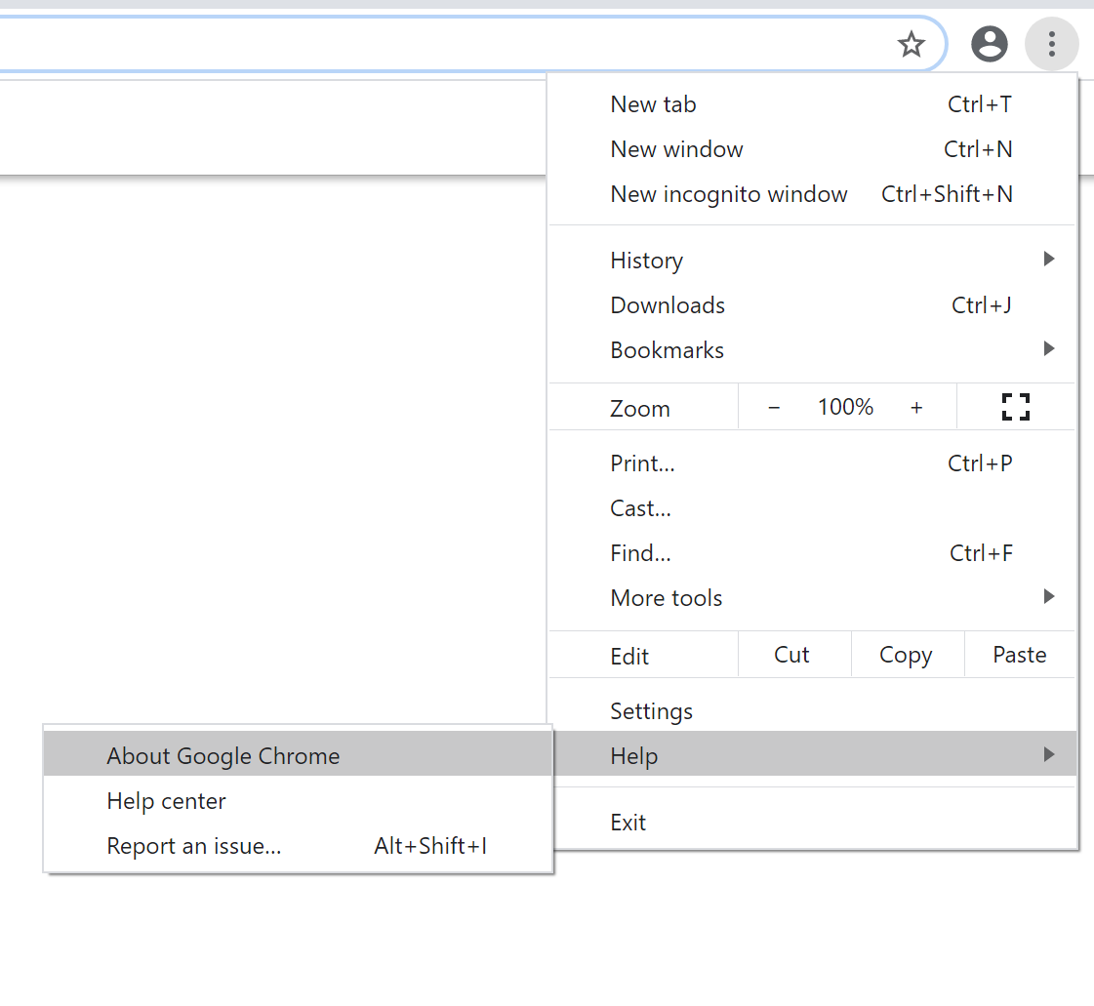

Turns out that I have Version 80, so we are going to download the driver for that version.

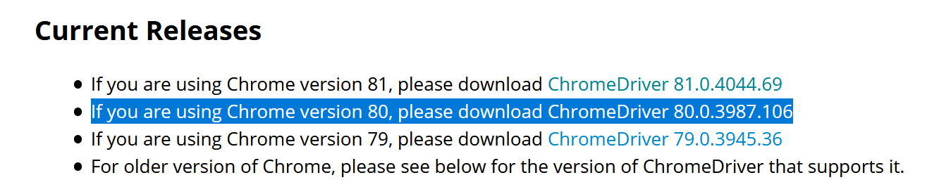

Now we got a zip file of the driver downloaded, we need to move that to the environment path. Now, you choose the path for the driver, but for me, I decided it to be “C:\Program Files\chromedriver”

The “chromedriver” here is the name of the folder that will contain the driver application from the zip file as seen below:

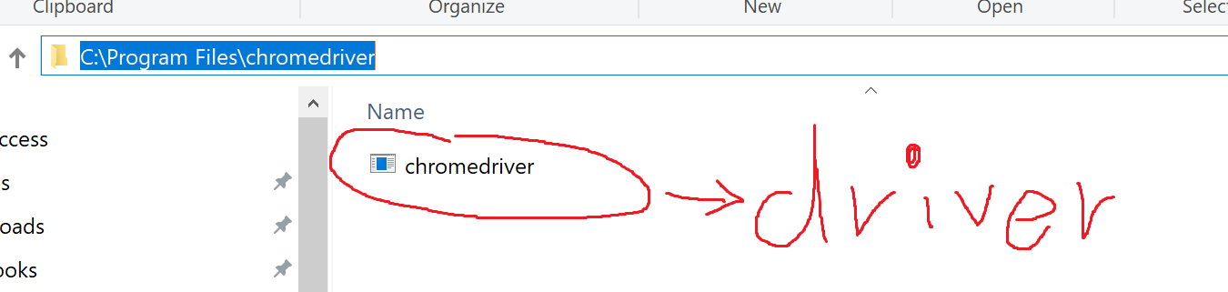

Pardon my amazing drawing skillz. Also, copy the path into your clipboard because we will paste it later.

Now let’s add this path to the Windows 10 system path. You can search this online, but allow me to show it to you if you’re too lazy. Go to the “Edit the system environment variables” of the control panel by just typing that in windows search.

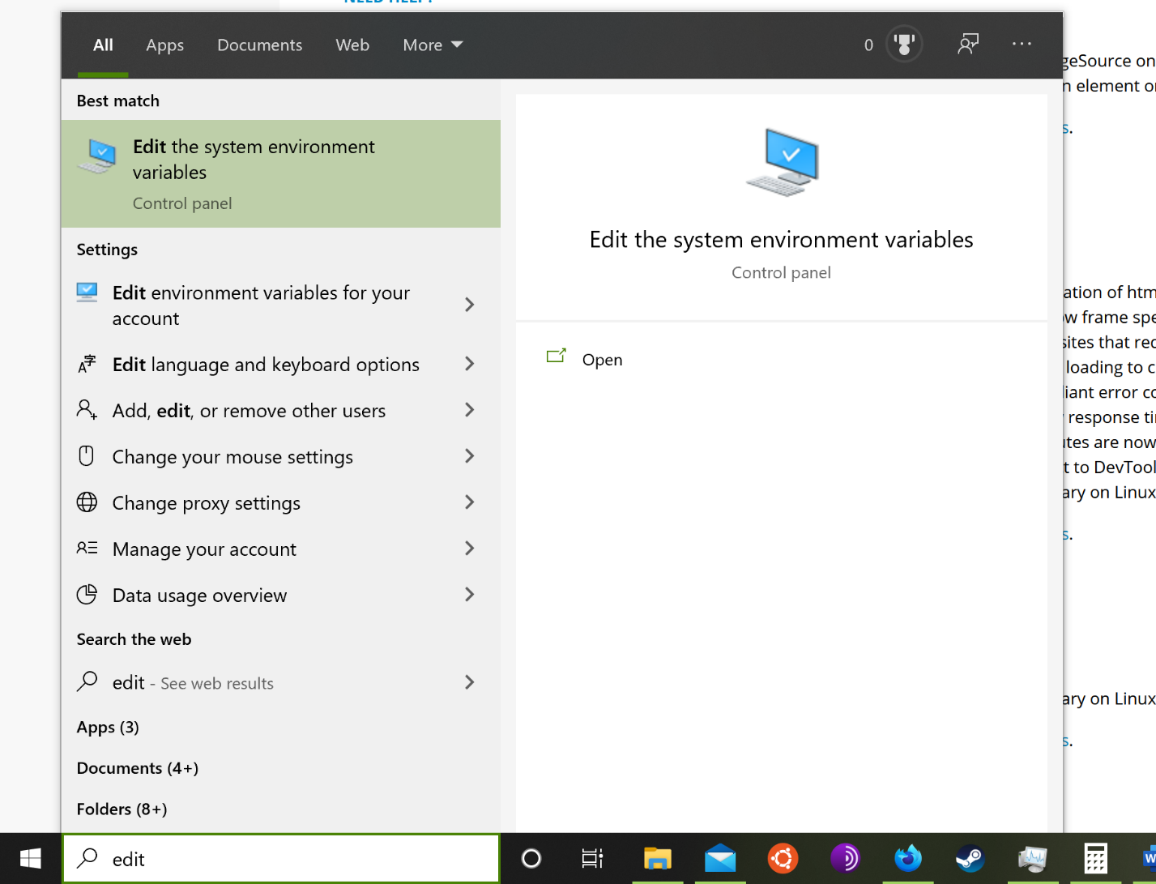

Then click “Environment Variables …” under “Advanced” tab.

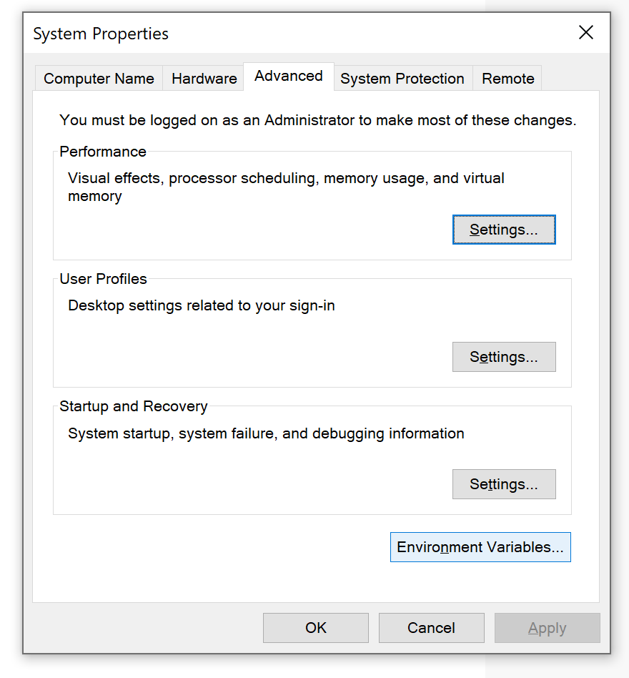

Then click the line that says “Path” under “System variables” and then click “Edit”.

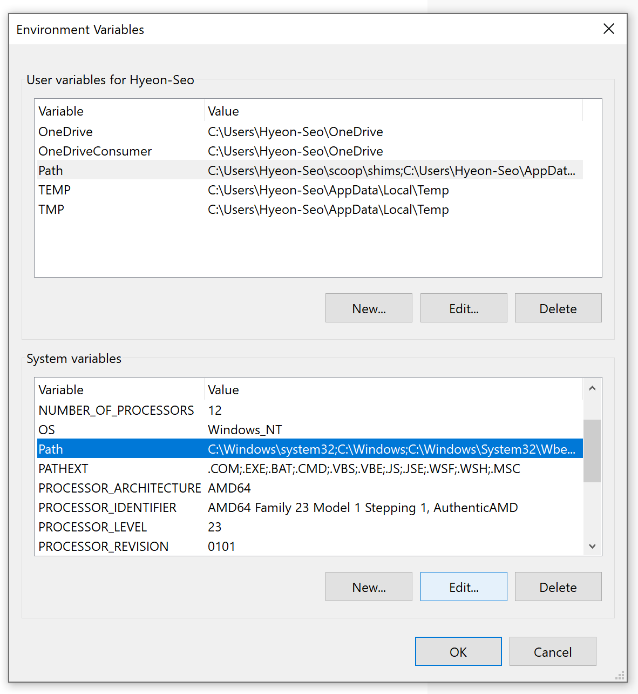

Then a new prompt will show up with pre-existing path variables. Click “New” to add another path variable, and write down the path of our chromedriver that you have copied previously, and then press “OK” to save the changes.

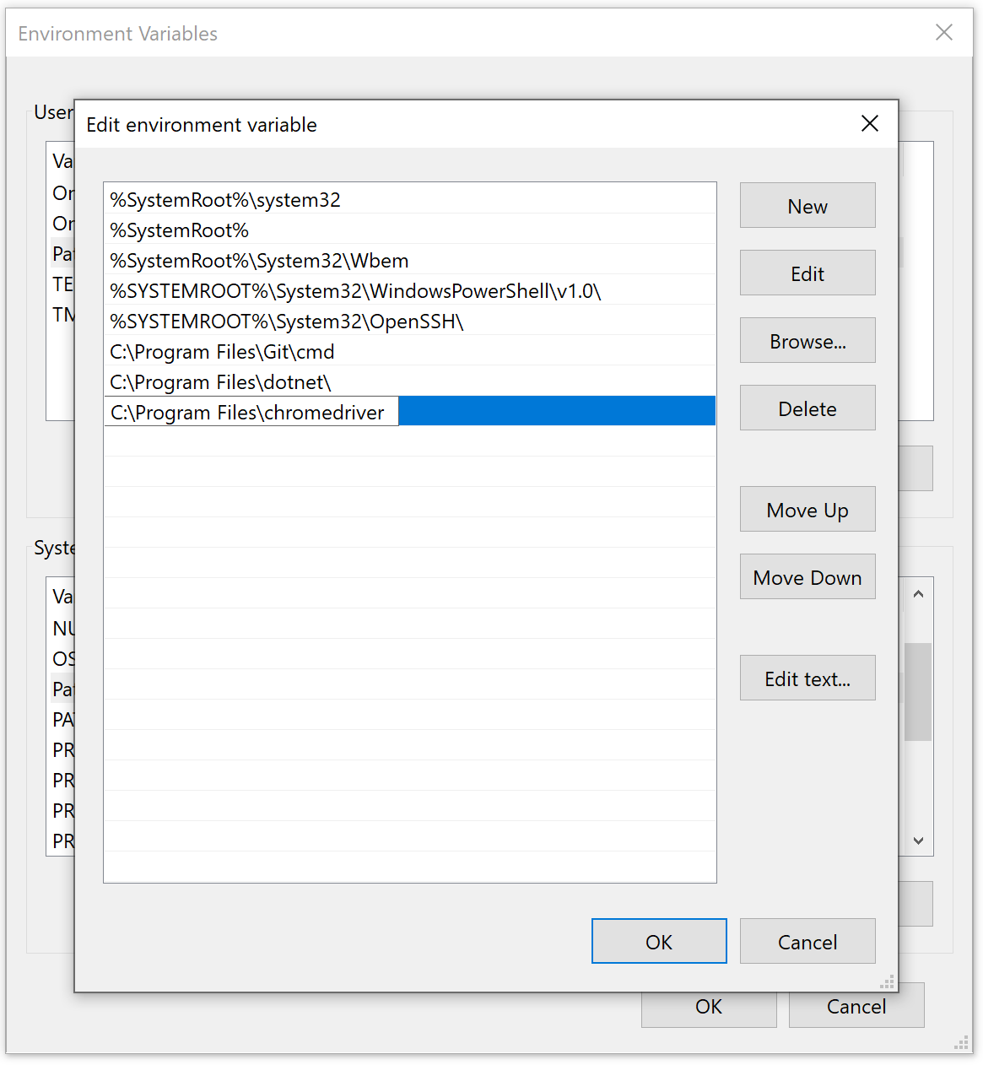

That’s it! Now the Browser driver is downloaded and its path is saved for Python to use it.

**Getting the Names of the Students You Want**

Before we use the program, we need to download the csv files (the program assumes that the files are in csv format) of the names of the students whose submissions you want downloaded. We only need to do this once. So let’s say we want to download students’ names in L068, L080, L085 and L108 (these are my lab sections 😊 ). The easiest way to do this is just download the grade center of the lab sections using Blackboard’s download offline feature.

Basically, go to the Phys 172 grade center, click on your lab group click “Work Offline” at the right and then “Download”:

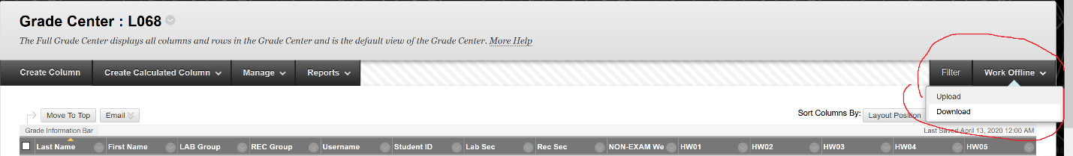

Then make sure the Delimiter type is “Comma” such that we get the csv file and then click submit.

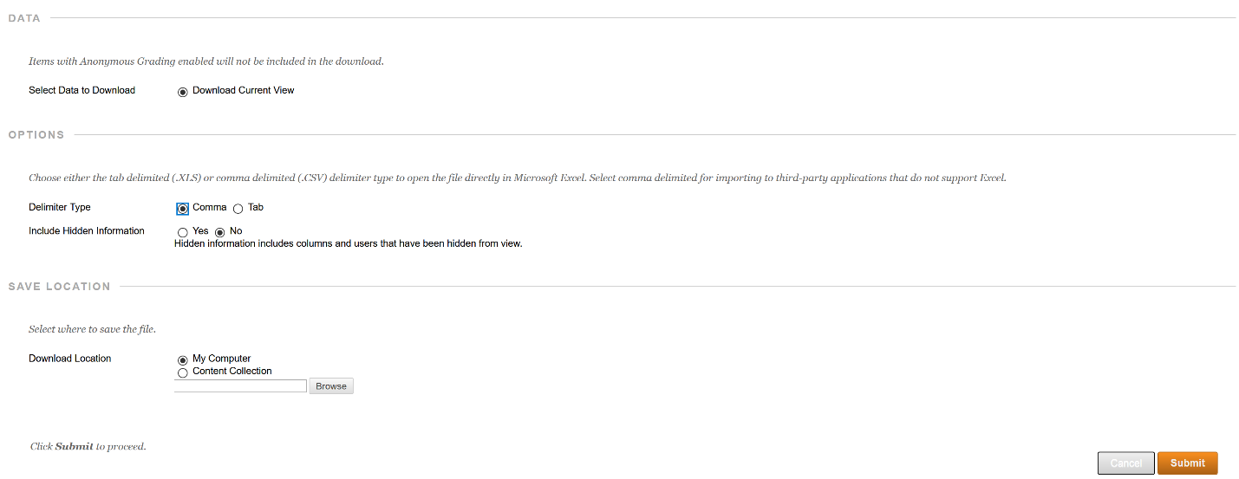

Do this with the rest of your lab sections. You’ll receive csv files for each lab. Please rename them appropriately because the csv files comes with very long names. I have named them “L068,” “L080,” “L085” and “L108.” Make sure you move these files in the same directory as the python programs:

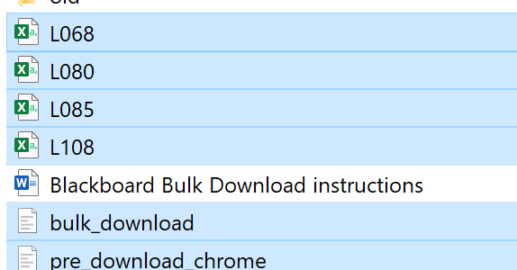

Furthermore, go ahead and open the python file “bulk_download.py” with a text editor of your choice. Don’t worry, you’ll only need to change one line; namely, the line with filenames. You’ll see that somewhere on the top of the file, the line goes:

filenames = ["L068.csv","L080.csv", "L085.csv", "L108.csv" ]

Replace the list of csv files written there into the names of csv files that you chose previously. If you are in charge of less than four lab sections, just delete the surplus csv file names. Don’t forget to save the changes.

**Using the program**

So now finally we get to use the code.

Basically, go to your terminal of choice, go to the program’s directory, and run the pre download code: “python pre_download_chrome.py” or “python3 pre_download_chrome.py” if your terminal differentiates python 2 and python 3.

This will open a remote session of chrome browser. Use that chrome browser to go to Blackboard, log in and go to the grade center for Phys 172. From the grade center, go to the tab with the lab submission you want to download.

Say, if we would like to download lab 9 submissions, we click the lab 9 tab, and then click on “Assignment File Download”

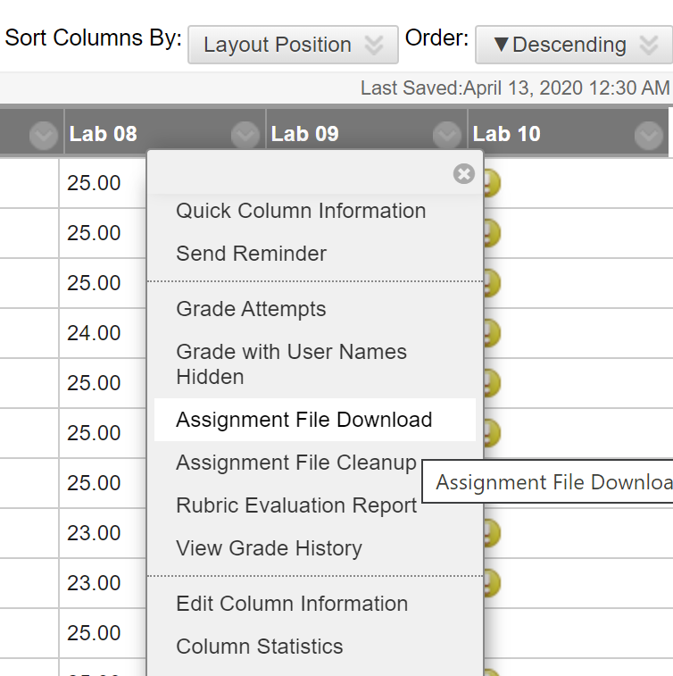

This will forward you to download assignment page. Here, you have a choice to download “Last attempt file” or “All attempt files” (idk why you’d get all attempt files, but you do you). **MAKE SURE** however, to click “Show All” button to show all of the students in one webpage:

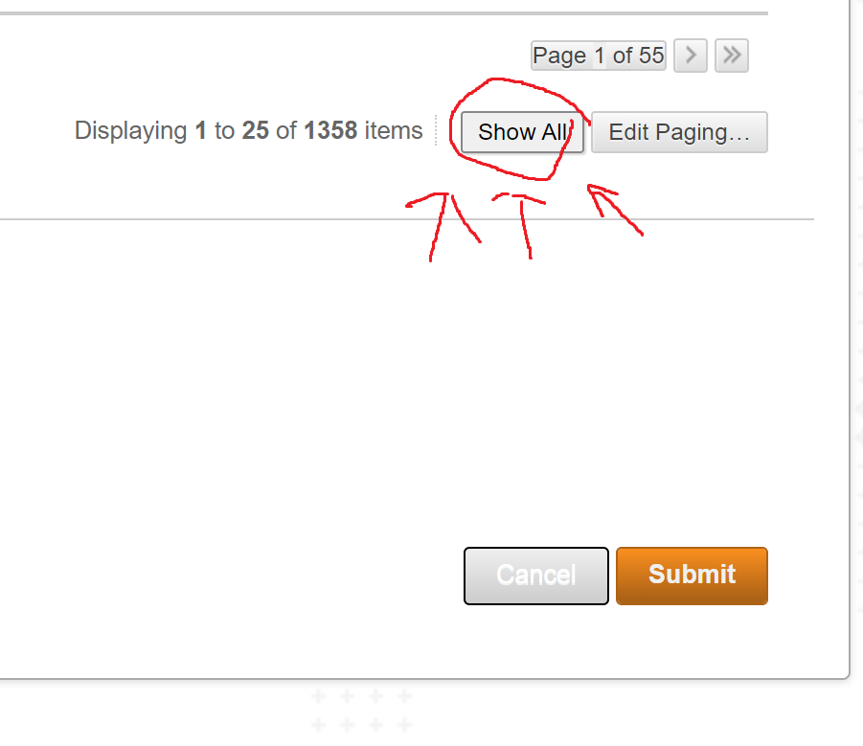

Go back to the terminal and run “bulk_download.py” So either “python bulk_download.py” or “python3 bulk_download.py”. Please note that the code will take some time to finish. The code will print “Done” in the terminal when it is done, in which case, you can log out of Blackboard and close the browser.

You should have received one zip file per csv file. Sadly, there’s no way to know which zip file is for with lab group from names alone. The solution is to look at the order in which they were downloaded. In you filenames list, the first csv files were downloaded first and vice versa. So, just sort the downloaded zip files in order of downloaded date, and you can know which file belongs to which lab section.

Please keep in mind that since the Selenium browser is in default setting, the zip files will be downloaded at the default directory. So, if you made a custom download directory, they won’t be saved there.

And that’s it! Thank you for your time, and hopefully this was useful, as I spent more hours on this than I would like to admit.